VP Harris backs plan to provide medical care for military PFAS victims

By Leo Shane III
Oct 22, 2024, 05:00 AM
Democratic presidential nominee Vice President Kamala Harris speaks with reporters before a town hall at the Royal Oak Theatre in Royal Oak, Michigan, on Oct. 21. (Jacquelyn Martin/AP)
Vice President Kamala Harris on Tuesday will publicly back plans to provide easier access to disability and medical benefits to veterans exposed to per- and polyfluoroalkyl substances, or PFAS, while serving in the military.
The move is a significant boost to the issue of groundwater contamination issues at bases around the country and follows on Harris’ work in President Joe Biden’s administration to better address military toxic exposure issues.
Harris’ support for the Veterans Exposed to Toxic PFAS Act — sponsored by Michigan Democrats Sen. Debbie Stabenow and Rep. Dan Kildee — came as part of a broader announcement of Latino-focused policies featured in her presidential campaign.
The legislation would require Veterans Affairs officials to provide “health care services and benefits to veterans exposed to PFAS at military installations.”

RELATED
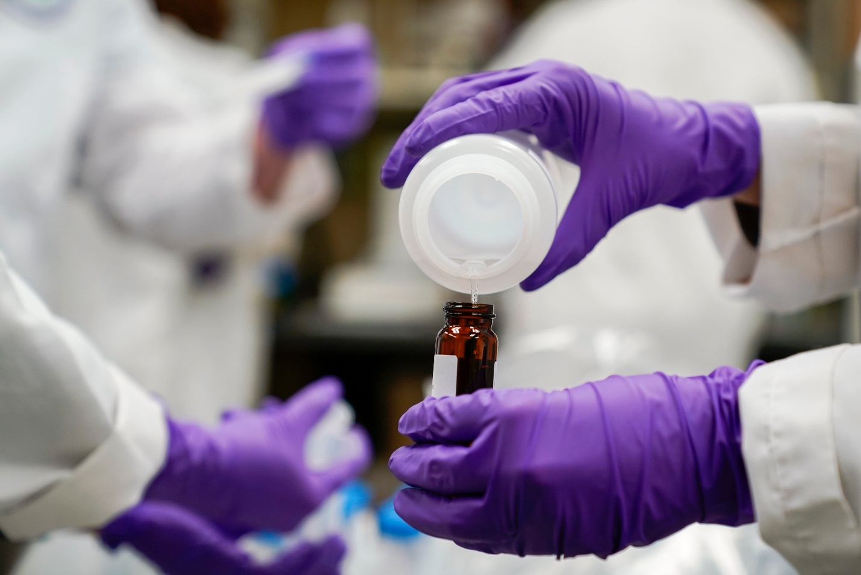

VA to research link between PFAS chemicals and kidney cancer

The move could eventually lead to fast-track disability benefits for thousands of veterans.
By Leo Shane III
The chemicals — used in a host of products like water-repellent clothing and firefighting foams — have been used widely on military bases for the last 50 years and are suspected to be the cause of a host of medical complications, including testicular cancer and thyroid disease.
Last month, VA leaders announced plans to research the link between kidney cancer and exposure to the chemicals, a move that could eventually provide presumptive benefits to thousands of veterans suffering from the illness.
But the Harris-backed legislation would speed up that process, specifically designating exposure to PFAS as a service-connected injury. That distinction is key to ensure eligibility for veterans benefits.
The bill specifically singles out ulcerative colitis, thyroid disease, testicular cancer, kidney cancer, high cholesterol and pregnancy-induced hypertension as conditions believed to be linked to PFAS exposure.
Family members of veterans stationed at bases where PFAS contamination was present could also be eligible for medical care from VA under certain conditions.
Outside advocates have estimated that as many as 700 American military bases worldwide have some level of PFAS contamination issues, potentially impacting hundreds of thousands of troops, veterans and their family members.
Officials with Harris’ campaign said she will also commission an assessment to investigate “the linkages between PFAS and illnesses impacting our service members.”

Eat 1 Teaspoon Every Night, See What Happens A Week Later [Video]Cardiologist: How to Quickly Lose a Hanging Bellygetfittoday.online

Dermatologist Begs Americans To "Fill In" Wrinkles With This Tip (Every Morning)Forget Retinol, Use This Household Item To Fill In Wrinkleswrinkles.pro
Two years ago, Biden signed the Promise to Address Comprehensive Toxics Act (PACT Act) which granted new disability benefits and medical care options to veterans who suffered illnesses from burn pit smoke, Agent Orange exposure and other chemical contaminations while in the ranks.
Those PACT Act provisions were a key focal point of Biden’s re-election campaign and have also been an issue of emphasis for Harris during military and veterans events.
President Donald Trump, Harris’ Republican opponent in the presidential campaign, has not publicly weighed in on the PFAS issue.

